Creating the first cluster node (Eman)



Creating the second cluster node (Fadi), and connecting both of them as a master and slave to establish gossiping.

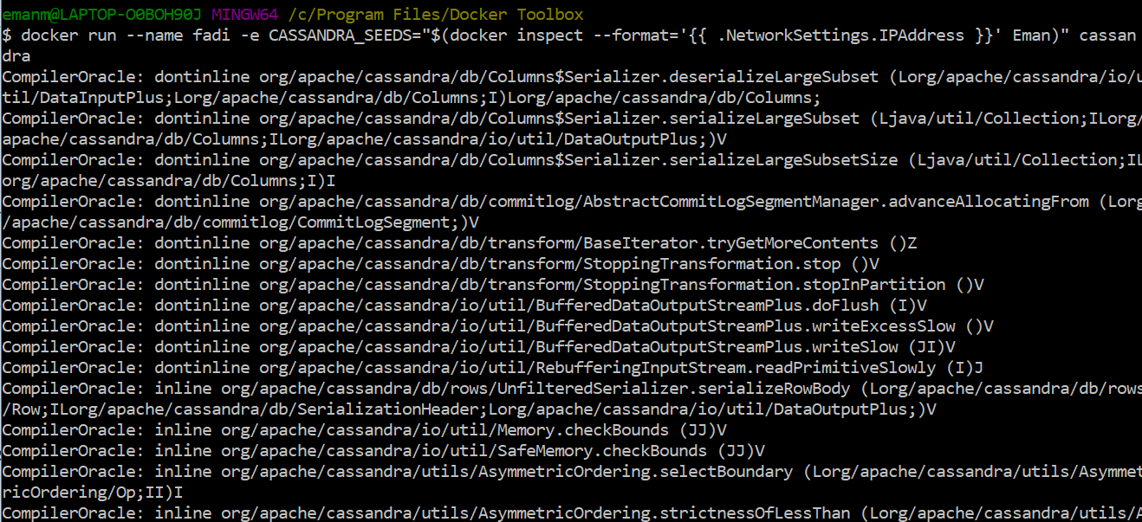

Showing the two nodes running

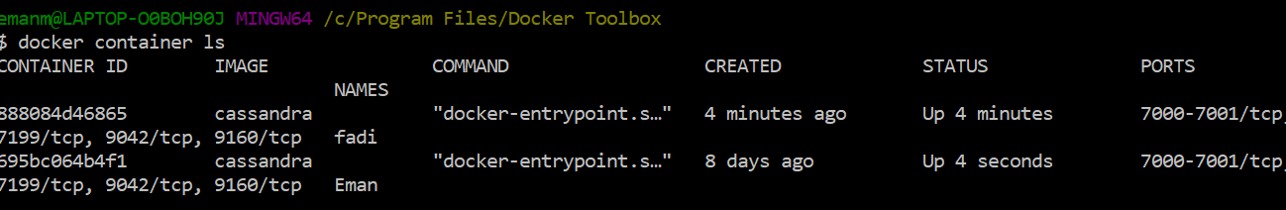

Creating a database for the hacker stories

CREATE KEYSPACE project_DB

WITH replication = {'class':'SimpleStrategy', 'replication_factor' : 2};

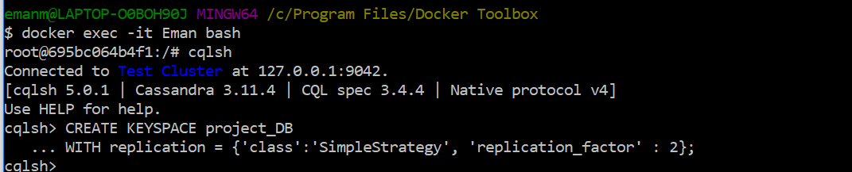

Using the project database

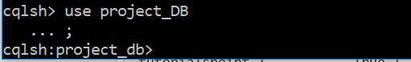

Data model

Creating the database to hold all needed data

**Table stories**

|  |  |
| --- | --- |
| **Column Name** | **Data type** |
|  |  |
|  |  |
|  |  |
|  |  |
|  |  |
|  |  |
|  |  |
|  |  |
|  |  |
|  |  |
|  |  |
|  |  |

CREATE TABLE project_DB.stories ( id int PRIMARY KEY, author text, by_name text, comments text, dead Boolean, deleted Boolean, descendants int, score int, time int, time_ts timestamp, title text, url text);  
  
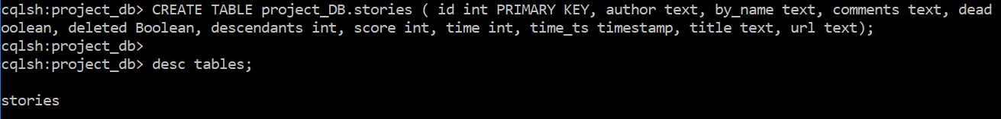

**Table DB.comments**

CREATE TABLE project_DB.comments ( id int PRIMARY KEY, author text, comment text, comment_by text, dead boolean, deleted boolean, parent_comment int, ranking smallint, time int, time_ts timestamp);

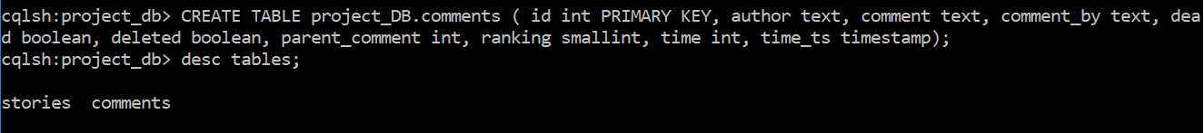

**Table full_table**

CREATE TABLE project_DB.full_table ( id int PRIMARY KEY, by_name text, comments text, parent int, time int, timestamp timestamp, title text);



All tables created in Cassandra

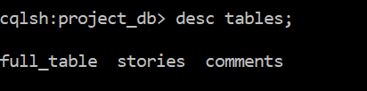

**Copy Sample of the Data**